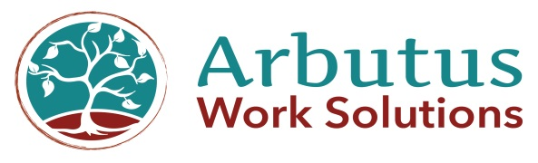
Partners in a healthy workplace

REPORTING REQUIREMENT AGREEMENT
BETWEEN

Client: And

Addiction Specialist: Dr. Robert N. Baker, Medical Review Officer and Arbutus Work Solutions Monitors: Donna Lee Sundby or Guylene Shaw

And
Employer: ________________________________
And

Agency: __________________________________

The above-mentioned parties recognizing that safety in the workplace is paramount and agree to the following reporting arrangement.

CLIENT: _______________________ gives the Medical Review Officer, Dr. Robert N. Baker and/or Donna Lee Sundby and/or Guylene Shaw permission to report to:
EMPLOYER/AGENCY: on a regular basis with respect to my progress in recovery from chemical dependency. Such reports may include:
1. A summary of recovery activities including 12 Step meeting attendance
2. Attendance at alcohol and drug counseling activities
3. The results of any formal drug screen testing
4. A professional opinion from the monitoring physician with respect to my overall progress
In addition to regular reporting, CLIENT __________________________understands that should there be significant concerns, Dr. Baker is obliged to report them to my employer as soon as reasonably possible.

Signed at ____________________________BC,

This _____________________day, of _________________, 20___

_______________________________________
Signature (CLIENT)

_______________________________________
Signature (ARBUTUS WORK SOLUTIONS)

430 – 5th Avenue, Kamloops BC, V2C 52Y Phone – (250) 299-3864/(250)682-0993, Fax - (250) 828-2992
Vancouver office: 1871 Alberni St. V6G 3H9 Phone (250)- 299-3864
www.arbutusworksolutions.ca

Restoring / Responsive / Accountable

